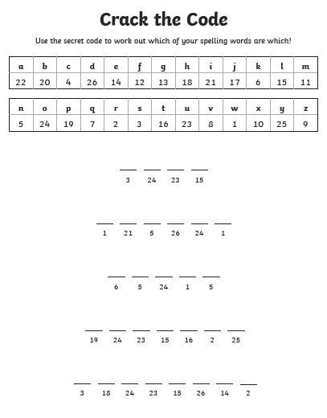

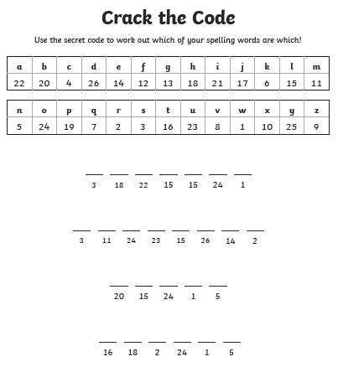

Challenge Task:
Which of your spelling words is missing? Use this missing word in a sentence that also has a modal verb!

