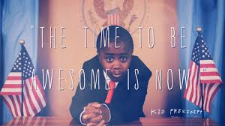

When I am kid president, I will make the world a more awesome place!

In order to do that, I shall change everyone’s way of thinking and I would make everyone think positively all the time.

I might let my baby sister live with me in my palace or castle but only if she asks nicely.

I should help people who are homeless by building more affordable houses and I could make it illegal to be rude to each other (that might be hard for my older brother!).

