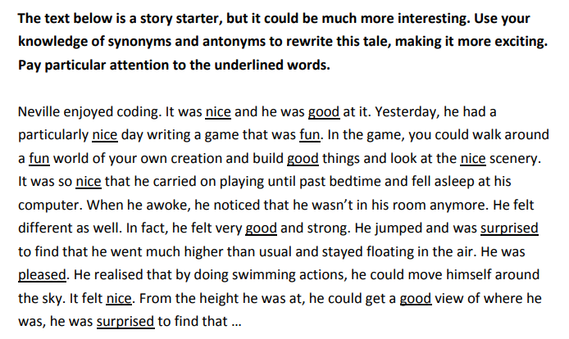

**These are some of the words you may want to use:**

friendly

good

repulsive

kindly

aloof

fun

pleasant

admirable

nasty

delightful

unlikeable

becoming

pretty

**Challenge**… can you continue the story?