Heathergarth Langar
SWEET SURPRISE
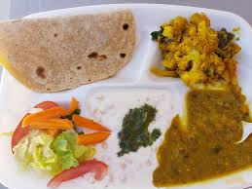
Fresh potatoes
Chopped tomatoes
Shredded lettuce
Mayonnaise – optional
Spicy Surprise
Hot spicy chili
Side of nan bread
Sweet salad (chopped up onions, shredded lettuce , sliced tomatoes and carrots)
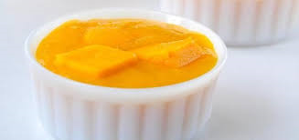
Delightful dessert Fruit-tuti surprise
Fruit cocktail
Fruit salad

Lydia and Tilly

