Langar Menu
THE HEATHER GARTH LANGAR

Starter

Pea Lentil soup with onion garnish
or
Onion Bhaji’s
Main

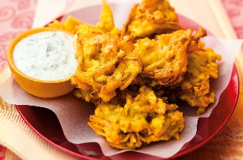
Vegetarian Curry With a naan bread
Or
Vegetable Stuffed pepper with naan bread
Dessert
Kheer with almonds on top
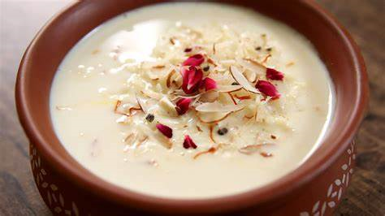
Kayden and Oliver

