Heather Garth Langar

Menu
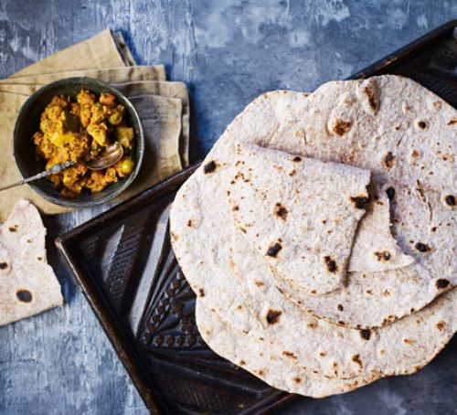
Starter - Special chapatti
A special chapatti with a nice refreshing curry sauce served with a hot chocolate

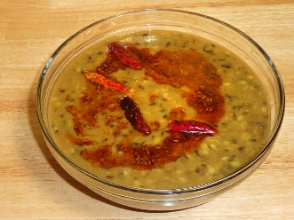
Main course - Langar surprise
A spicy mix dal with pieces of garlic nan bread served with a glass of water
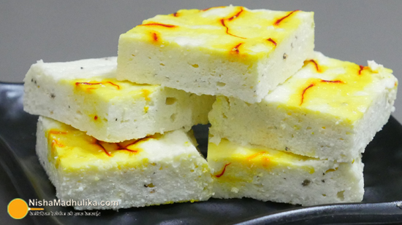
Dessert - Creamy delight
A sweet Sandesh with a creamy filling of strawberry jam with vanilla icing, served with a nice hot cup of tea.
Grace and Alex G
Everything’s better at the Langar!

