Langar | 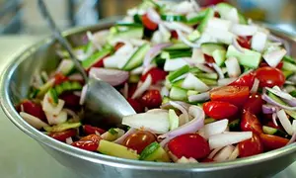  SALAD SURPRISE
Starter  SALAD SUPRISE  Tomatoes, Sweetcorn, Lettuce,  Cucumber, Peppers.  Main Course  VEGTABLE CURRY  Garlic, potatoes, carrots, peppers, coli flour, peas, sweet potatoes,  DESSERT  THE DELICIOUS ONE  Vanila ice cream, brownie  Charley and Alex L | 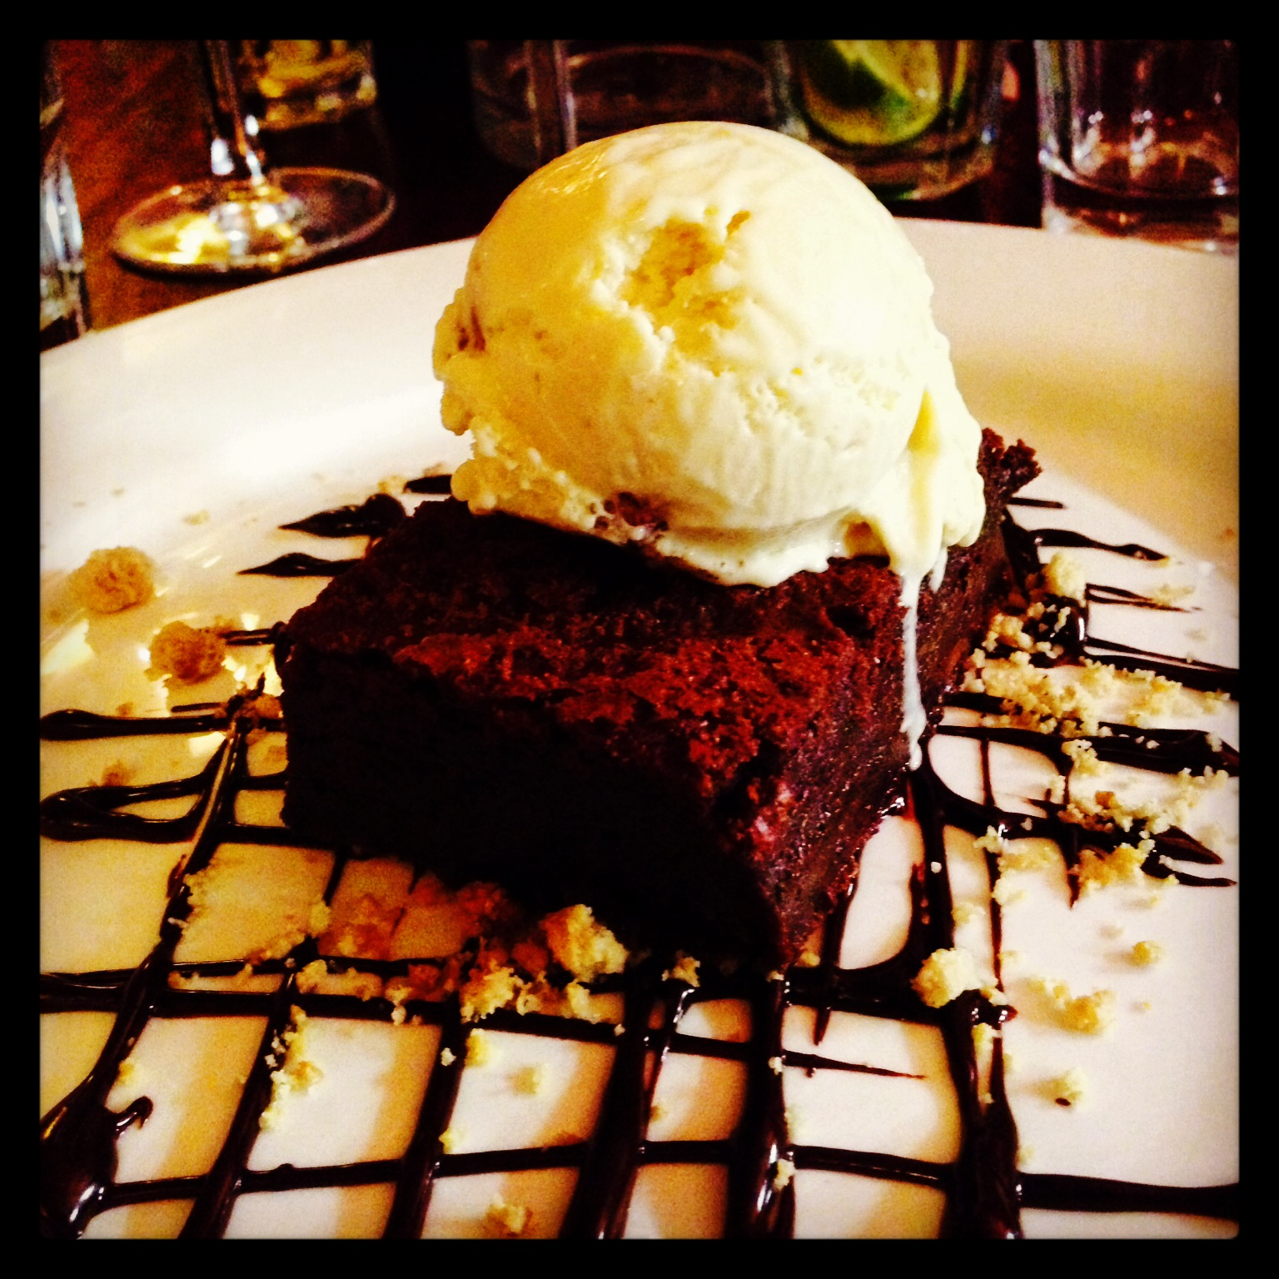  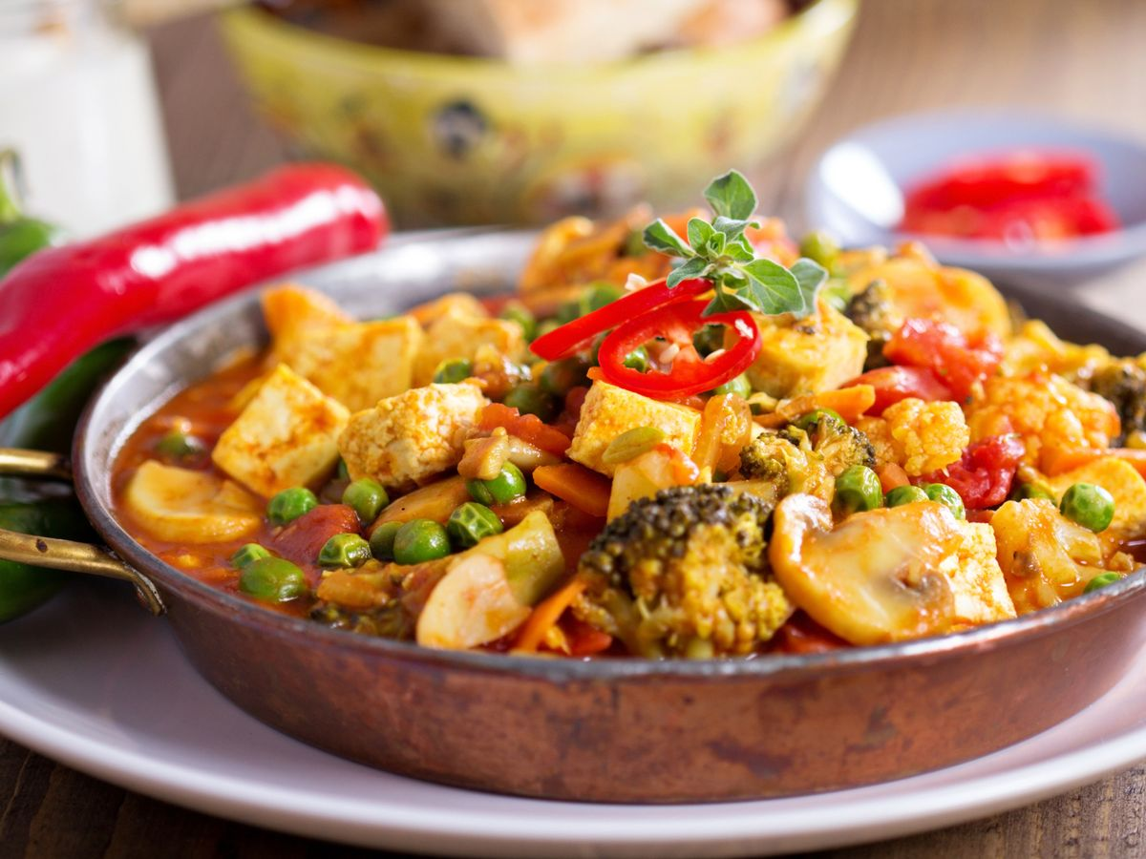  VEGTABLE CURRY  THE DELICIOUS ONE
,

