Anna and poppy | Menu
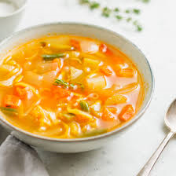
THE FEASTED LANGAR
Starters:
Vegetable soup

Finest roast vegetable with a soupy source.
Vegetable curry.

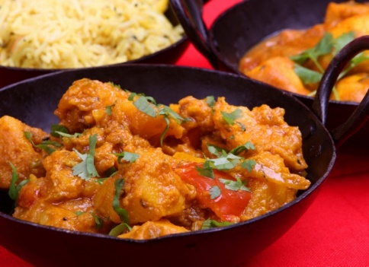
For Mains:
Delicous vegetables covered in a mouth dripping spicy curry sauce, served with beautiful naan bread to make your mouth sing with glee.
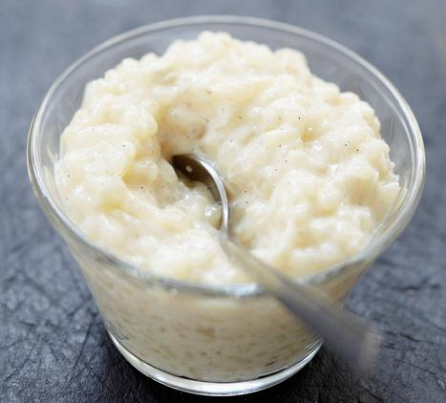
For pudding is rice pudding
Amazing pudding for everyone to enjoy.

jj

