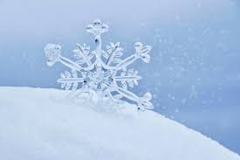
FS2 Snow Day Activities

Here are some ideas to support your learning at home today. If you could pick 5 (one for each area of learning) that would be great. Enjoy the day, have fun and learn lots in the snow!

Literacy

- Share a snow story with someone in your house – talk about the plot e.g., what is happening, predict what might happen next, talk about how the characters feel.

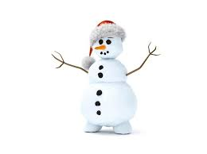
- Read your books from your school book pack or use these videos to help with remembering your sounds:
https://www.youtube.com/watch?v=-ZtjFIvA_fs
https://www.youtube.com/watch?v=qDu3JAjf-U0
https://www.youtube.com/watch?v=DvOuc7cWXxc

Maths

- Create a repeating pattern in the snow – use sticks and stones, draw shapes and repeat the pattern in the snow.

- Play a maths game e.g. Teddy Numbers or Underwater Counting on Topmarks Early Years: https://www.topmarks.co.uk/Search.aspx?Subject=37

Understanding of the World

- Make some snowballs, making sure they are the same size. Using different materials e.g. tea towel, kitchen foil, newspaper or kitchen roll. See if you can predict which snowball will last the longest before melting.

Personal, Social and Emotional Development/Communication and Language
- Play a game together e.g., dominoes – can you take turns with each other and talk about what is happening as you play?

- Create your own story using different toys/teddy bears – what is your story about? What will happen next?

Expressive Arts and Design
- Draw/paint a picture showing yourself playing in the snow with your family (write a label/caption to describe your picture e.g. ‘I love playing in the snow’, ‘The snow is soft’.

- Make your own snowman outdoors – using different materials add details e.g., a nose, buttons. Take a photo of your creation!

